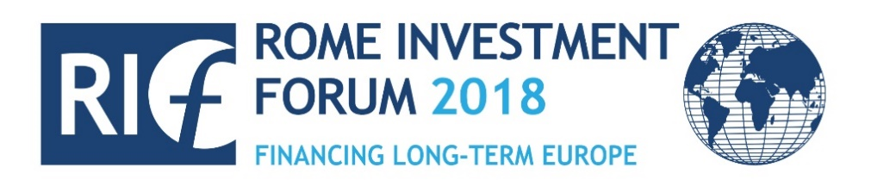

ROME INVESTMENT FORUM 2018
Financing Long-Term Europe

INVEST IN EUROPE
Rome
14-15 December 2018

Scuderie di Palazzo Altieri
Via Santo Stefano del Cacco, 1

#RIF2018

Organized by
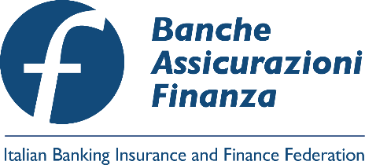
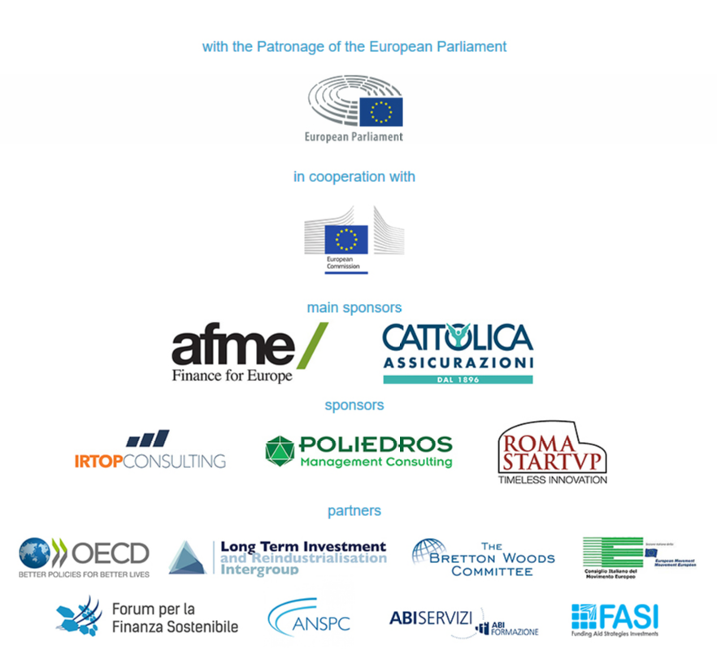

Formazione professionale continua
Il Rome Investment Forum 2018 è accreditato presso l’Ordine dei Commercialisti e degli Esperti Contabili di Roma per l’ottenimento di crediti formativi per la formazione professionale continua.

Europe is at a cross-road. The legacy of mixed results and missed opportunities of the last twenty years is complex to deal with. In 2019, amid uncertainties and threats - old and new- the next European legislature and Parliament will take shape and get started. With what goals and mandates? With what visions and tools? In what socio-political context? And what can Italy contribute and benefit?
In projecting the outlook, the national, European and global dimensions appear inextricably intertwined, and yet not necessarily converging. The worlds of private initiative and public policy, financial intermediation and the real economy, social cohesion and competitiveness are facing distinct challenges of modernization and pressures to change. But they often lack a clear perception of the sense and the terms of their mutual interdependence and multiple partnerships.
Are national communities responding to the challenges of social polarization, the digital divide, exclusion and life-long learning? Is Europe capable of fixing the pitfalls and filling the gaps of its fledgling construction? Can she have an authoritative voice contributing to stability and prosperity in a growingly unsettled world?
These questions must be addressed urgently and in-depth. That is what we aim at in the fifth edition of the Rome Investment Forum. Stimulating an informed discussion, supported by robust expertise and an awareness of the long-term trends of economic and social development. Above all, building trust and credible perspectives of regeneration and reform, which requires reaching out to a wide spectrum of communities, interests, opinions and sentiments. Starting with the different members of the financial community, i.e. banks, insurance companies, financial markets, pension funds, real estate and investment funds, advisors and stock brokers, and all other components of the associations that are affiliated to the Italian Banking Insurance and Finance Federation. Academics, policy-makers, entrepreneurs, opinion makers, and ordinary citizens, many of which are engaged with us in a journey of dialogue and learning interchange, nationally and internationally, which we highly value and which find in the Rome Forum a moment of catalysis and climax.
Invest in Europe. Because investment is at the center of the on-going strategies of reform. And Europe is the destination, or perhaps the destiny, of our passage towards a future of greater prosperity, peace and security.
Investment is needed to expand production capacity and potential output, increase jobs and the quality of life, modernize the industrial structure, bolster infrastructure, tangible and intangible, physical network and social, to protect the environment and fight social exclusion.
But investment requires finance, i.e. a healthy robust and advanced financial sector. Investment without sound financing is nothing more than an empty promise and a waste of resources. Investment financing requires adjustments on the demand and supply side of the equation. The financial sector must play its unique role: raise and channel savings, make them safe and profitable, ensure the quality and sustainability of investment, link the needs and interests of savers and investors, tax-payers and beneficiaries of public subsidies, bridge supply and demand, the present and the future.
The post-crisis recovery has unearthed a new set of financial challenges, technological opportunities and socio-economic gaps. Also, a new world of political realities. The “new normality” calls for new thinking and innovative business strategies. New policy approaches and forms of collaboration between regulators, clients, providers and entrepreneurs. New banking models and insurance contracts, new partnerships between banks insurers and financial markets, new cross border activities, distribution arrangements, customer relations, new data collection and utilization strategies, and a renewed sense of ethics in dealing with savers, investors, institutions and the public opinion. Only a new wave of responsible and forward-looking investment, supported by a well-functioning financial sector, can make this quantum transformation possible and sustainable.
2019 – the year of the European elections - will provide a historic opportunity for taking stock of what we have achieved or failed, and what we have learned in the process, without any complacency nor victimhood. The backlog of unfinished business and unresolved contradictions of the last twenty years will inevitably spill-over into the next phase, hopefully with a more determined commitment to bring about solutions. This means at the EU level strengthening fiscal capacity, fixing the Euro, completing the Banking Union, advancing the Capital Market Union, extending the Investment Plan both in terms of resources and geographic scope particularly towards our near abroad, the Euro-Mediterranean and Eastern Europe, reforming Schengen and Dublin, etc. With what level of ambition? What deliverables? What perceived impact on the ordinary lives of citizens? And would this be enough to carry the support of the disenchanted middle classes and polarized local communities?
The latter part of the past century left an ambitious agenda of visionary projects making up what Rifkin (an American) called “the European dream”: the Enlargement – both East-West and North-South -, the Single Market, Social Europe, the Single Currency, etc. The first part of this century has seen the accomplishment – albeit partial- of several of those projects, but at the same time their deadlock and the surrender to the Dream. A dream is not a dream without a credible plan, but a plan is not a plan without a feasible dream. What we are left with then is broken dreams and shallow plans. This inevitably has consequences on investment, because investment requires both a vision of the future and a realistic roadmap, i.e. both a dream and a plan.
The Rome Forum aims at reconstructing a perspective conducive to investment growth, jobs and welfare, in Italy, in Europe and in the global economy, and discussing how to create an enabling environment for that. Homework starts at home: the “revolution” in the Italian financial sector, which started in the 1990’s and has recently accelerated, must go on, aimed at strengthening open profitable competitive advanced and innovative financial intermediaries and markets, promoting alternative sources of funding, channeling savings towards innovation, long-term assets and the modernization of the real economy. What are the conditions internal and external for this “revolution” to continue?
But the discussion will also focus on European reforms and global challenges. The two go together. Not so much because we need a more muscular “European Sovereignty”, alongside national sovereignties, for the power games of a multipolar, and dangerous, world. But because European leadership can uphold new integration and governance models based on a multinational community of law, freedom, democracy and a shared commitment to the future. This is what keeps us together, a Covenant that even though not carved in the stone of a written Constitution was signed by the Founding Fathers with the still fresh and tragic memory of the blood spilled in the European civil wars of the 20th century.
We dedicate the final session to the memory of Kofi Annan, who passed away in August, where speakers who had the privilege of working with him discuss how to make multilateralism effective, inclusive and supported by the people.

DRAFT AGENDA
Friday 14th December
8.30 - 9.00 | Registration and welcome coffee

 | Opening
9.00 - 9.15  Welcome Address | Luigi Abete, Chairman, Italian Banking Insurance and Finance Federation (FeBAF)
9.15 – 13.00 | Morning Sessions
9.15 – 11.00 | Perspectives for 2019: Where Are We Going, and Where Do We Want to Go
Main Topics | - Economic and socio-political perspectives  - The future of Europe: options, risks and challenges  - Geopolitical risk scenarios: national, European, global  - Is Europe capable of contributing to global leadership and governance?  - 2019, a crucial year: elections, Brexit, end of unconventional policies, migration challenges, trade conflicts, threats to peace and security, etc.
Keynote Speakers | Vincenzo Boccia, Chairman, Confindustria  Beatrice Covassi, Head, European Commission representation in Italy  Michael Cole-Fontayn, Chairman, Association for Financial Markets in Europe (AFME)  Maria Bianca Farina, Chairwoman, Italian National Association of Insurance Companies (ANIA)  Daniel Gros, Director, Centre for European Policy Studies (CEPS)  Gian Maria Gros-Pietro, Chairman of the Board of Directors, Intesa Sanpaolo  Alessandro Rivera*, General Director of the Treasury, Ministry of Economy and Finance, Italian Government
11.15 – 13.00  Sala della Clemenza | New Patterns and Partnerships for Financing Infrastructure Investment
Main Topics | - Is there a gap in infrastructure spending and finance? At the EU level? At the national level?  - What role for banks, insurance and financial markets?  - Is there a European space for infrastructure investment and financing?  - How do we respond to segmentation and non-harmonized standards, regulation and supervision?  - Are institutional investors coping with the challenges? What risks and opportunities?  - The Juncker Plans: past, present and future  - The regulatory and supervisory frameworks
The gap of infrastructure investments in Italy and in Europe: are we on track? | Chair: Giovanni Sabatini, General Manager, Italian Banking Association (ABI) - Chairman of the Executive Committee, European Banking Federation (EBF)  Franco Bassanini, Executive Chairman, Open Fiber  Carlotta De Franceschi, Chairwoman, Action Institute  Francesco Mazzaferro, Head of European Systemic Risk Board Secretariat, European Central Bank (ECB)  Luigi Paganetto*, Vice Chairman, Cassa Depositi e Prestiti  Dario Scannapieco, Vice President, European Investment Bank (EIB)
Financing instruments and models and public private partnership | Chair: Dino Pesole, Columnist, Il Sole 24 Ore  Emanuela Claudia Del Re, Vice Minister of Foreign Affairs, Italian Government  Domenico Arcuri, Chief Executive Officer, Invitalia  Lorenzo Bini Smaghi, Chairman of the Board of Directors, Société Générale  Antonio Caponetto, General Director, Agenzia per la Coesione Territoriale  Silvia Maria Rovere, Chairwoman, Assoimmobiliare  Laurent Zylberberg, Director of Institutional, International and European Relations, Caisse des Dèpôts
11.15 – 13.00  Scuderie Palazzo Altieri | Re-building the Social Contract and Repairing Social infrastructures
Main Topics | - Social infrastructures: new models of financing  - Responsible investment and sustainable finance: comparison of best practice  - The instruments: not just Social Bonds  - ESG variables and non-financial reporting as leverage for better accountability and risk management  - The link between sustainable development goals (SDGs), green finance and resilience strategies  - Public-private partnerships for the reduction of catastrophic risks
Policy frameworks and business strategies  to build resilient economies and societies | Chair: Paola Albrito, Chief Regional Office for Europe, United Nations Office for Disaster Risk Reduction (UNISDR)  Daniela D’Andrea, Chief Executive, Swiss Re Italy  Agostino Miozzo, Director Promotion and Integration of the National Service, Civil Protection Department, Presidency of the Council of Italy  Roberto Paciotti, Country Manager S&P Global Ratings Italy  Edoardo Reviglio, Chief Economist, Cassa Depositi e Prestiti  Matthias Schäfer, Head of Team Financial Policy and Labour Market Policy, Konrad Adenauer Stiftung  Eutimio Tiliacos, Secretary General, Foundation Centesimus Annus Pro Pontifice  Valter Trevisani, General Manager, Cattolica Assicurazioni
Sustainable finance, education and investment: where do we stand? | Chair: Gianfrancesco Rizzuti, Head of Communication and Institutional Relations, Italian Banking Insurance and Finance Federation (FeBAF)  Arnaud de Bresson, Chief Executive Officer, Paris Europlace  Raffaele Della Croce, Senior Economist, Organisation for Economic Co-operation and Development (OECD)  Pietro Negri, Chairman, Italian Sustainable Investment Forum - Legal counsel, Italian National Association of Insurance Companies (ANIA)  Roberto Ridolfi, Special Advisor on Strategy and Financing Development, Food and Agriculture Organization of the United Nations (FAO)  Pierluigi Stefanini, Chairman, Gruppo Unipol - Chairman, Italian Alliance for Sustainable Development (ASviS)  Mark Thatcher, Professor, Luiss University and London School of Economics and Political Science
13.00 – 14.00 | Lunch

14.00 – 18.15 | Afternoon Sessions
14.00 – 15.45  Sala della Clemenza | Financing Growth Potential and Employment in Italy: the Focus on SMEs and Competitiveness
Main Topics | - Business finance and access to capital markets  - What role for industrial policies: cross-border consolidation, global value chains, privatization and the local eco-systems  - Size matters: financing business expansion and networks  - The role of institutional investors: welfare reforms at the European and national level  - Alternative fundings, private equity and private debt, venture capital, etc
Financing modernization and employment creation: the role of SMEs | Chair: Ferdinando Giugliano, Columnist, Bloomberg Opinion  Giulia Bertezzolo, Secretary General, Commissione Nazionale per le Società e la Borsa (CONSOB)  Corrado Passera, Founder and Chief Executive Officer, Illimity Bank  Luca Peyrano, Chief Executive Officer, ELITE – London Stock Exchange Group  Leonardo Rubattu, General Director, ICCREA Banca S.p.A.  Alessandro Settepani, Country Head, FitchRatings Italy
The new competitiveness challenges: funding requirements and opportunities | Chair: Janina Landau, Editor-in-chief, Class CNBC  Antonio Angioni, Co-founder and Senior Partner, Poliedros Management Consulting  Carlo Bonomi, President, Assolombarda  Innocenzo Cipolletta, Chairman, Italian Private Equity, Venture Capital and Private Debt Association (AIFI)  Anna Lambiase, Founder and Chief Executive, IR Top Consulting  Massimo Ungaro, Member of the Finance Committee, Italian Parliament
14.00 – 15.45  Scuderie Palazzo Altieri | Innovation of Financial Services as Leverage for Industrial Modernization and Competitiveness
Main Topics | - Market and business models under pressure: threats and opportunities  - Innovation and financial inclusion  - Insurtech: is the sector ready? What are the opportunities and the challenges?  - How to face cybersecurity challenges?  - Fintech: the challenge between incumbents and new entrants  - Fintech and sandboxes: more than a regulatory conundrum
Keynote Speaker  Financial innovation shapes the world... | Greg Medcraft, Director of the Directorate for Financial and Enterprise Affairs, Organisation for Economic Co-operation and Development (OECD)  Chair: Antonia Carparelli*, Economic Governance Advisor, European Commission representation in Italy  Loredana Guglielmetti, Head of National and European Patents and International Patent Applications, Italian Ministry of Economic Developmen  Luigi Morgano, Member of the Committee on Culture and Education, European Parliament  Carlos Ignacio Montalvo Rebuelta, EMEA Insurance Risk and Regulatory Leader, Pricewaterhouse Coopers  Alessio Terzi, Associate Fellow, Bruegel  Pehr Wissén, Senior Advisor, Swedish House of Finance
… the world of innovation needs financing | Chair: Pierfrancesco Gaggi, Chairman, ABI Lab  Gianmarco Carnovale, Chairman, Roma Startup  Elio Catania, Chairman, Confindustria Digitale  Massimo Di Tria, Chief Investment Officer, Cattolica Assicurazioni  Patrizia Toia, Vice Chair of the Committee on Industry, Research and Energy, European Parliament
16.00 – 18.15 | Plenary Session
 | Fixing the European Dream: Economic and Monetary Union, Banking Union, Capital Markets Union, and What Else?
- What to be expected in the future for the Eurozone and the EU as a whole?
- Automatic stabilizers and counter-cyclical policies: how fiscal policies influence stability and growth
- Completing the Banking Union. Risk Reduction and risk sharing: synergies, trade-off and compromises
- Capital Markets Union: can we make progress without more ambitious transfers of sovereignty?
- PEPP: opportunities for all?
- European Supervisory Authorities (ESAs): the review. The perspectives of regulators, industry, institutions and consumers.

Guests of Honour | Pierre Gramegna, Minister of Finance, Luxemburg Government  Roberto Gualtieri, Chair of the Committee on Economic and Monetary Affairs, European Parliament  Giovanni Tria*, Minister of Finance, Italian Government  ***
What is the vision for the next European legislature? Priorities and deliverables | Chair: Roberto Sommella, Journalist and Writer  Ignazio Angeloni, Member of the Supervisory Board, European Central Bank (ECB)  Gabriel Bernardino, Chairman, European Insurance and Occupation Pension Authority (EIOPA)  Didier Cahen, Secretary General, EUROFI  Hung Tran, Executive Managing Director, Institute of International Finance (IIF)  Rick Watson, Managing Director, Association for Financial Markets in Europe (AFME)
Can economic and financial reforms make a difference in the everyday life of European citizens? How and why? | Chair: Rainer Masera, Dean of the School of Business, Marconi University  Mark Garvin, Vice Chairman for the Corporate & Investment Bank, J.P. Morgan  Josè Manuel Gonzalez-Paramo, Executive Board Member, Banco Bilbao Vizcaya Argentaria (BBVA)  Andrea Montanino, Chief Economist, Confindustria  Bernard Spitz, President, French Insurance Federation (FFA) - President International & Europe, Movement of the Enterprises of France (Medef)
19.30 – 22.00 | Social Event

Saturday 15th December
9.00 - 9.30 | Registration and welcome coffee

09.30 – 13.00 | Morning Session
9.30 – 9.45 | Award Ceremony  Rome Investment Forum Empowers Talents 2018
9.45 – 10.00 | Defending the Rules-based International-cooperation Global Order. Or Building a New One?
Guest of Honour | Enzo Moavero Milanesi*, Minister of Foreign Affairs, Italian Government
10.00 – 11.00 | Making Multilateralism Effective and Inclusive: What Lessons from the Past and What Reforms for the Future
Introduction | In commemoration of Kofi Annan: former Secretary General of the United Nations  Paolo Garonna, Secretary General, Italian Banking Insurance and Finance Federation (FeBAF) - former Deputy Executive Secretary, United Nations Economic Commission for Europe (UNECE)  ***
Margareta Wahlström*, Chairwoman Swedish Red Cross - former Assistant Secretary General for Humanitarian Affairs, Office for the Coordination of Humanitarian Affairs (OCHA)
José Antonio Ocampo, Board Member, Banco de la República Colombia - Chair, of the United Nations Committee for Development Policies (CDP) - former UN Under Secretary General, United Nations Department of Economic and Social Affairs
Antonio López-Istúriz White, Secretary General, European People’s Party (EPP)
Carlo Cottarelli, Director Observatory on the Italian Public Accounts, Università Cattolica del Sacro Cuore of Milan
Randy S. Rodgers, Executive Director, Bretton Woods Committee

11.00 – 12.30 | Europe’s Role on the Global Exchequer: Values, Business Responsibilities, Institutional Cooperation
Main Topics | - Global and European imbalances: how to redress them  - Completing the post-crisis regulatory reforms of the financial sector: what next? Implementation? Supervision?  - Multilateralism, regionalism and bilateralism: what vision? And leadership?  - Relaunching the Transatlantic relationship: the financial sector perspective  - Brexit: short-term and longer-terms concerns and prospects  - Europe’s near abroad: looking East and South  - Is there still a Euro-Mediterranean dimension for the EU? And an Eastern Europe one? What perspectives for financial markets integration?
European Union and its neighborhood policies | Chair: Giuseppe Scognamiglio, Chairman, Eastwest European Institute  Ahmed Alkarm, President, Tunisian Professional Association of Banks and Financial Institutions (APTBEF)  Brando Benifei, Member of the Committee on Employment and Social Affairs, European Parliament  Francesca Maria Corrao, Professor, Luiss University  Goran Svilanovic, Secretary General, Regional Cooperation Council (RCC)  Cesare Trevisani, Chairman, Joint Italian Arab Chamber of Commerce (JIAAC)
The role of the European Union in the global and transatlantic relations | Chair: Domingo Sugranyes Bickel, President, Foundation Centesimus Annus Pro Pontifice  Lorenzo Cesa, Member of the Committee on Foreign Affairs, European Parliament  Marco Committeri, Senior Director International Relations and Economics, Bank of Italy  Pier Virgilio Dastoli, President, Italian Council of the European Movement (CIME)  Alberto Minali, Chief Executive Officer, Cattolica Assicurazioni  Randy S. Rodgers, Executive Director, Bretton Woods Committee  Karl-Peter Schackmann-Fallis, Executive Member of the Board, Deutsche Sparkassen und Giroverband (DSGV)
12.30 | Conclusion

The Italian Banking Insurance and Finance Federation - FeBAF
The Italian Banking, Insurance and Finance Federation - FeBAF is the common house of savings and finance in Italy, bringing together the major domestic financial associations. It was established in 2008 by the Italian Banking Association (Abi) and the Italian Association of Insurance Companies (Ania). FeBAF currently associates also Adepp, Aifi, Aipb, Assofiduciaria, Assofin, Assogestioni, Assoimmobiliare, Assoprevidenza, Assoreti, Assosim.
The Federation fosters the role of banking, insurance and financial intermediaries, while promoting general interests. A modern and efficient financial sector is an important condition for the advancement and sustainable growth of society and the economy. The Federation aims at presenting in a coherent and systematic way its members’ views on economic and social policies, and engaging in a dialogue with institutions, political and monetary authorities, trade associations and public opinion in Italy, Europe and worldwide. It promotes business values, seeking to spread the culture of competition, and focusing on the enhancement of banking, insurance and finance in terms of transparency and responsiveness towards its stakeholders. Due to its international profile, the Italian financial industry strengthens its dialogue with other organizations in Europe.

