Centesimus Annus – Pro Pontifice (CAPP)
Deutschland

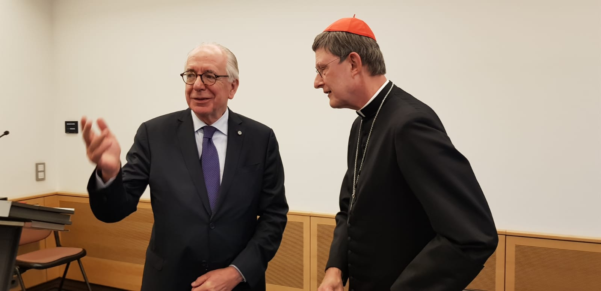
President Sugranyes Bickel, Card. Woelki

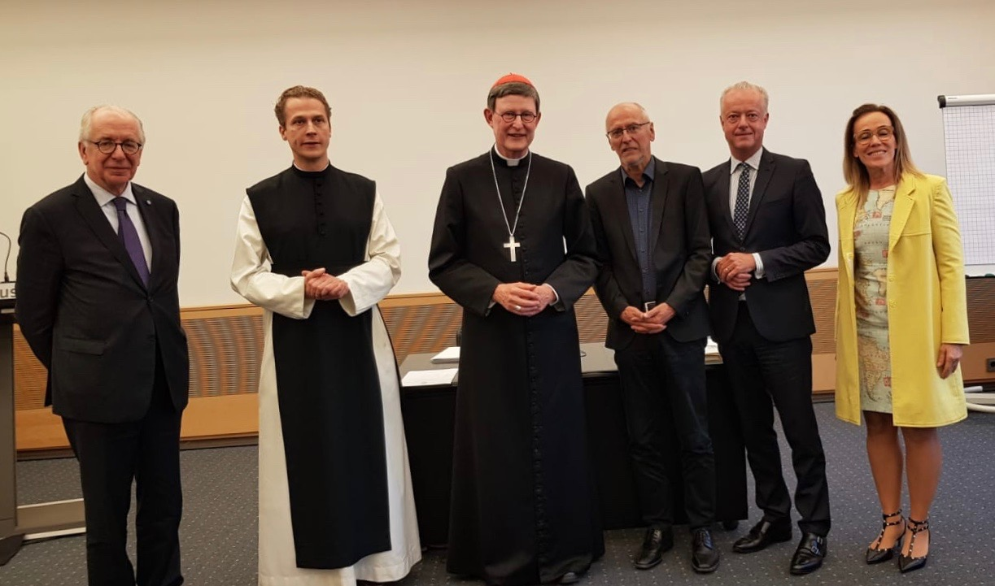
D. Sugranyes Bickel, P. Justinus C. Pech, Card. Woelki, Prof. Grunwald, Th. Rusche, E. Bonacossa
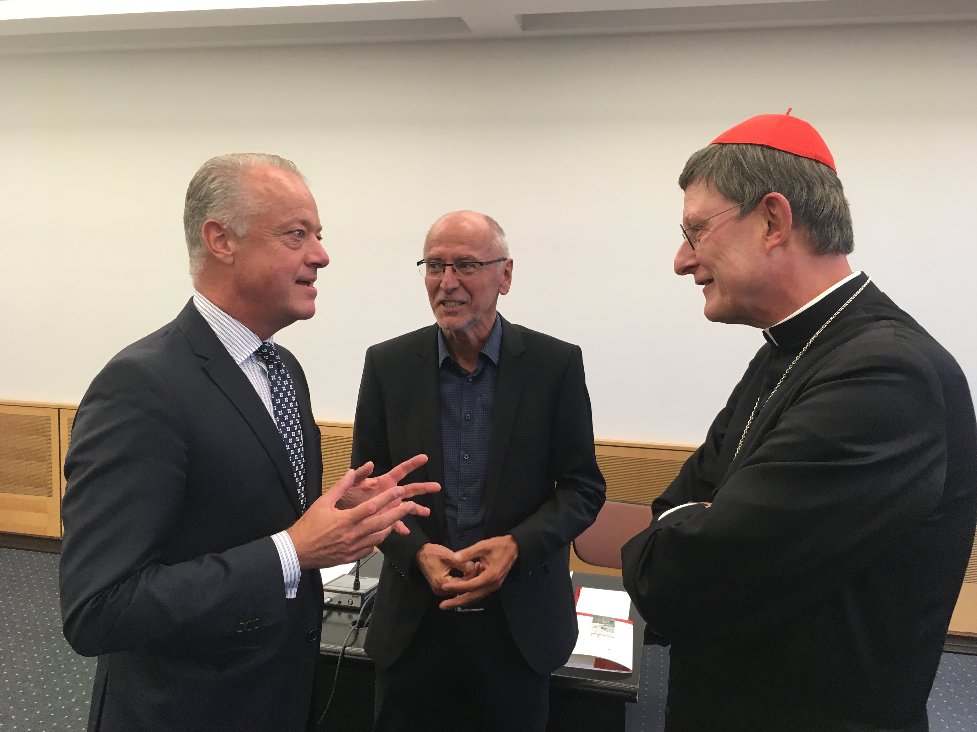
Th. Rusche, Prof. Grundwald, Card. Woelki

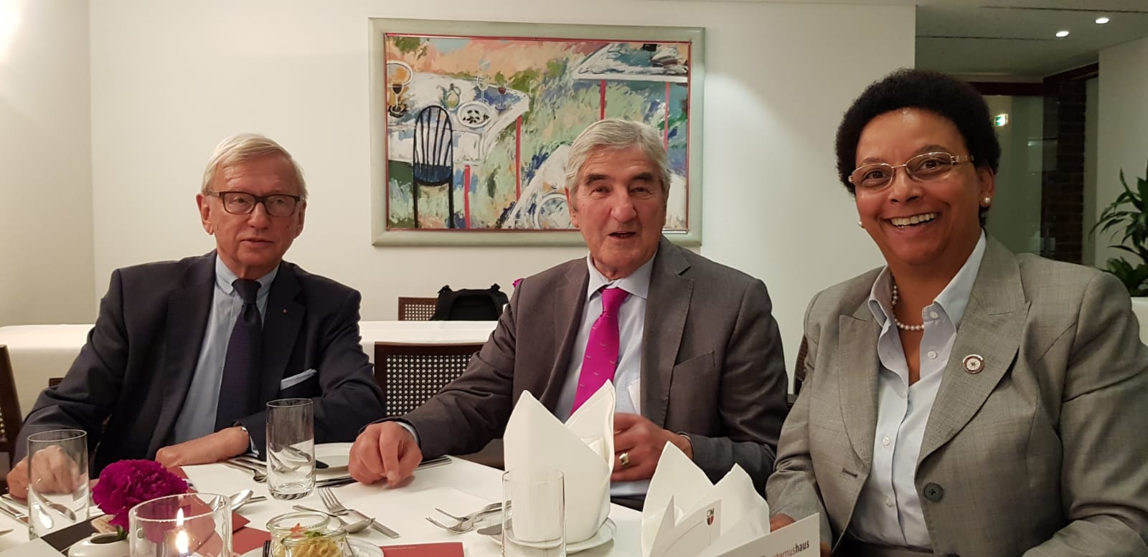
Detlef Brümmer, Fuerst Loewenstein, Dorothea Boehm
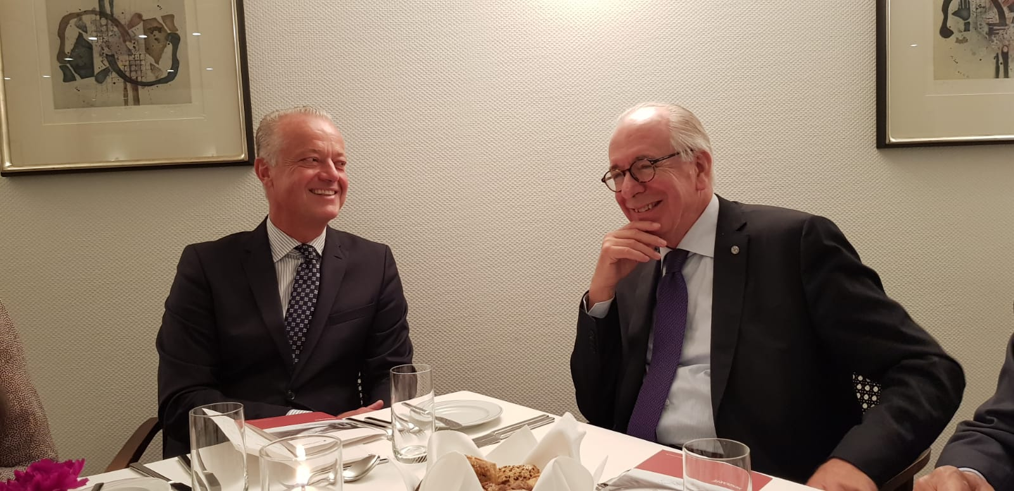
Th. Rusche, D. Sugranyes Bickel

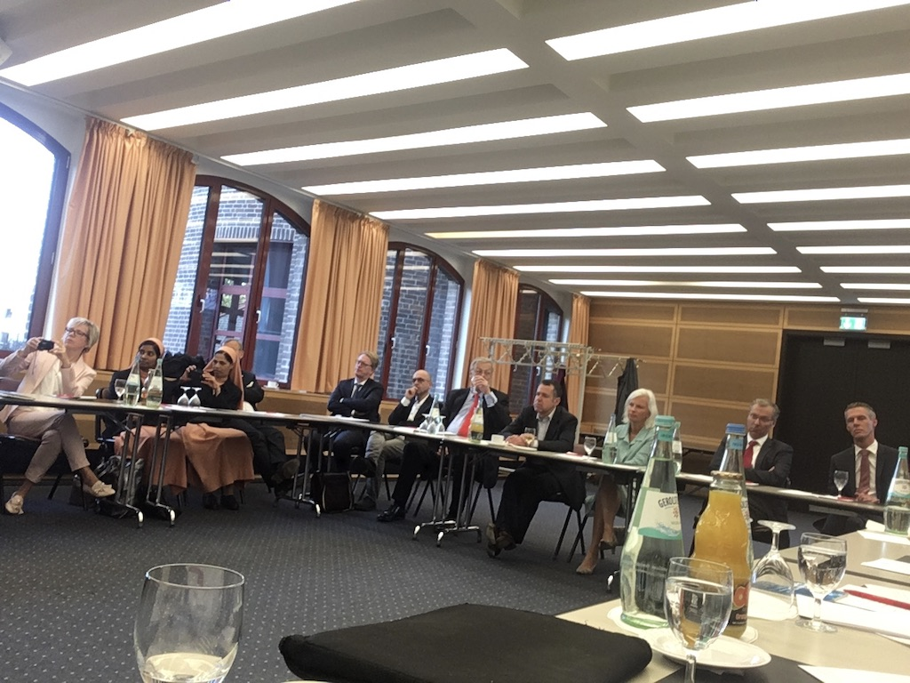
Audience

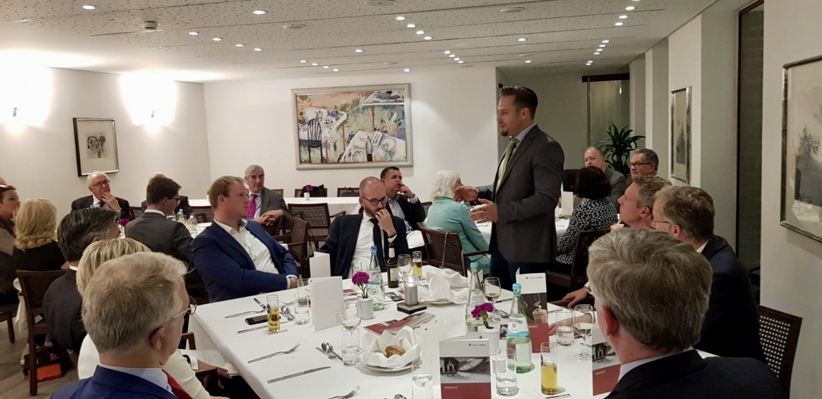
Dinner

