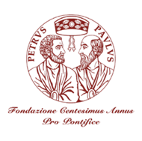
CAPPF 2022 Consultation
Paris, March 24th- 25th, 2022

BUILDING AN INCLUSIVE GLOBAL ECONOMY:
THE ROLE OF BUSINESS COMPANIES
Protecting the poor, the vulnerable and promoting sustainable prosperity

Institut Catholique de Paris
21, rue d'Assas 75270 PARIS Cedex 06 FRANCE

Open Session Amphitheatre

REGISTRATION FORM

FAMILY NAME__________________________________________________________________
GIVEN NAME ___________________________________________________________________
OCCUPATION ___________________________________________________________________
ADDRESS (Street) ________________________________________________________________
CITY____________________________________________________________________________
ZIP CODE_________________________________
EMAIL _________________________________________________________________________
MOBILE______________________________________________________________________
I will take part to the Open Session 25th MARCH 3:00 PM – Institut Catholique de Paris Amphitheatre Room

Date ___/___/2022 Signature _________________________
Please fill form in BLOCK LETTERS and send scanned copy by email to Fondazione Centesimus Annus – Pro Pontifice centannus@foundation.va

